

**COM2041-B**

**PROGRAMMING LANGUAGE CONCEPTS**

**Lex and Yacc**

Tuğçe Nur ŞAHİN-Mehmet KEKEÇ

Objective of my homework is teaching basic principles of compilers and making practice on BNF. For achieving this objective, I prepared lex, yacc and file which has example program of my programming language.

Homework was done on Linux operating system. The order of the commands I will specify in the last section are the commands to be made in the Linux operating system.

In the Lex file, expression tokens, logical operators etc. are defined. The basic structure of the Lex file looks like this:

• “**dongu**” return **DONGU**;

• “**yazdir**” return **PRINT**;

**Green:** The command/phrase in the language. Regular expressions can be used here, but if regular expressions are used, the quotation marks at the beginning and end of the green text should be removed.

**Black:** When green text called in the program, it throws the token which is black.

Tree parsing method was used in the Yacc file. You can see the sample scheme of tree parsing in

Figure1.



Figure 1. Tree Parsing Scheme

New expressions / expressions can be defined in the Yacc file or only symbols defined in the yacc file can be used. When sorting trees, their flexibility and diversity should be taken into account. For example, the programmer should prefer to reference predefined statements / expressions rather than using multiple "OR" operators. Also, when refining lex and yacc files, people should save and test their files at short intervals because it will be difficult to fix the code after making too many changes.

**For compiling the files**;

$ lex 15290122.l

$ yacc -d 15290122.y

$ gcc -o test y.tab.c -lfl

$ ./test < example.c

The sample document shown below was created according to the rules. If this file is run, **"OK"** will appear on the compiler screen.

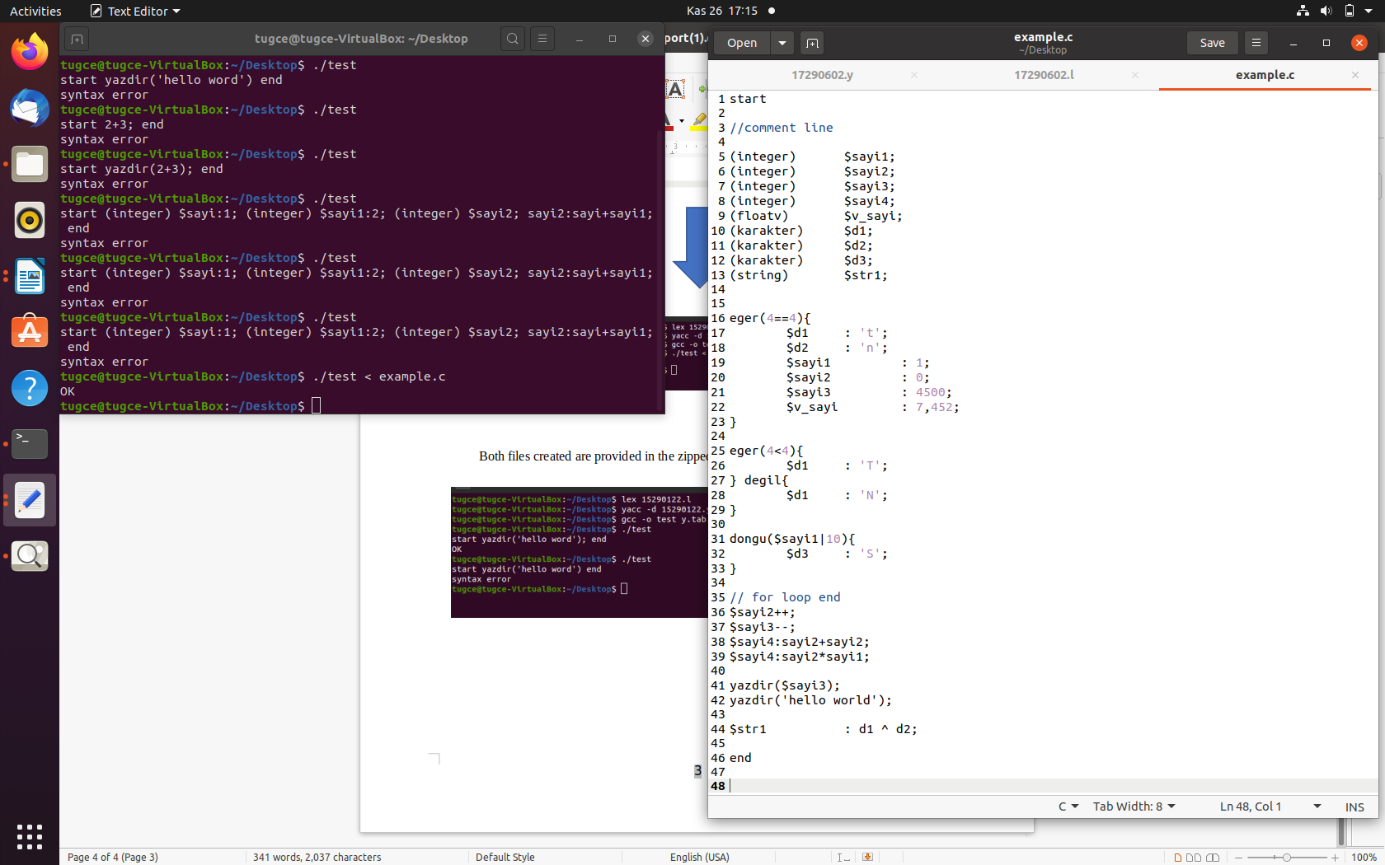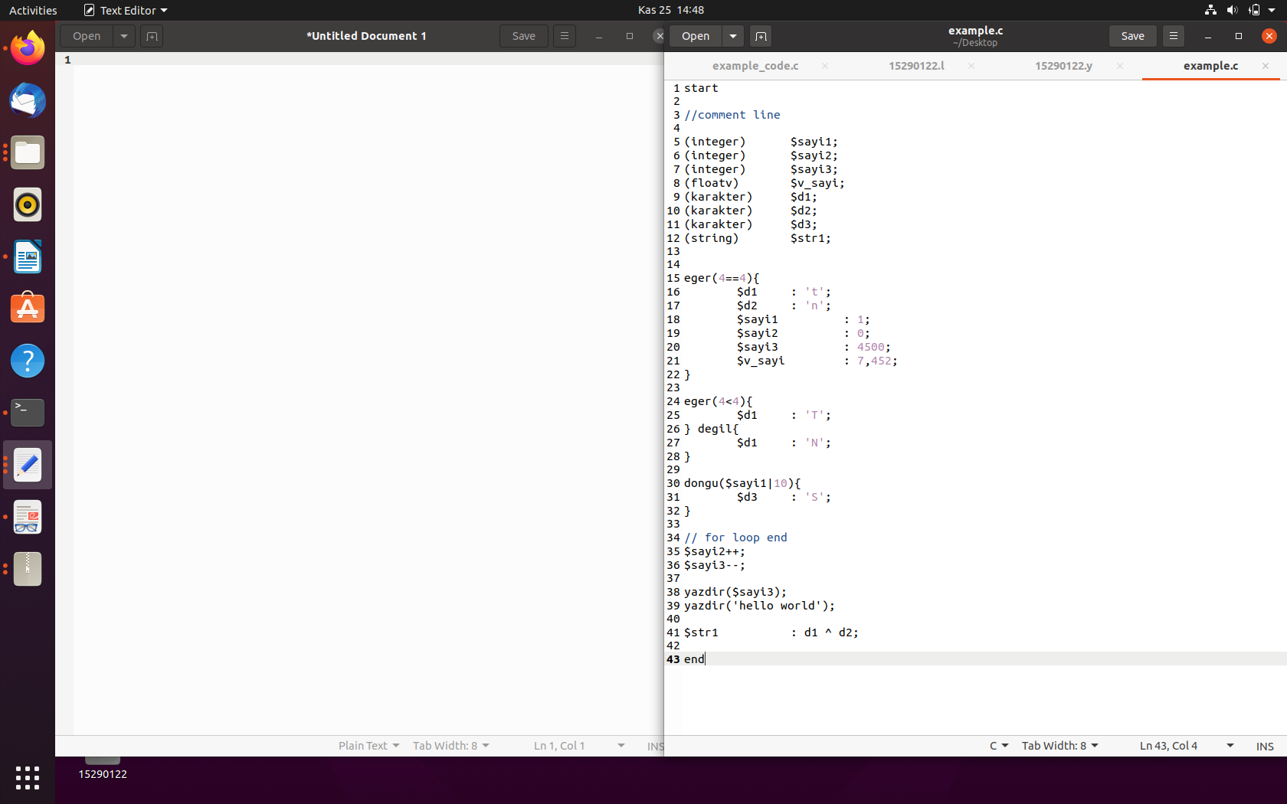

Figure 2. example files

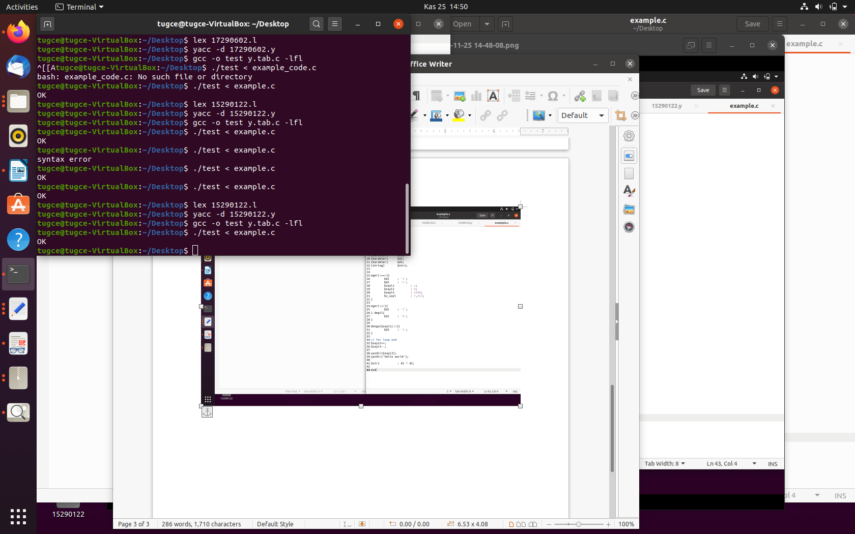

Figure 3. Compiler showing that the example file works correctly when executed

The error document shown below contains statements that do not comply with the rules. Therefore, **"syntax error"** will appear on the compiler screen.

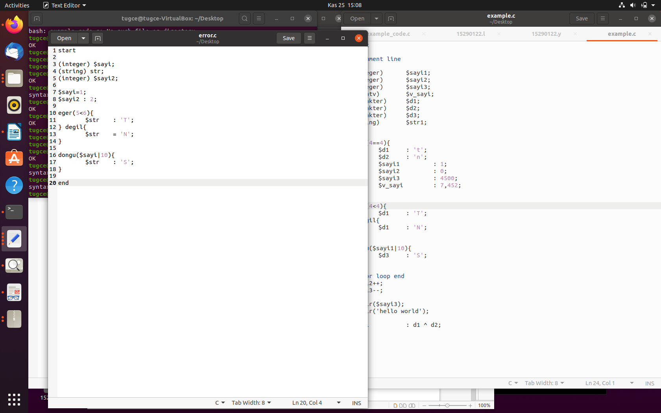

Figure 4. error file

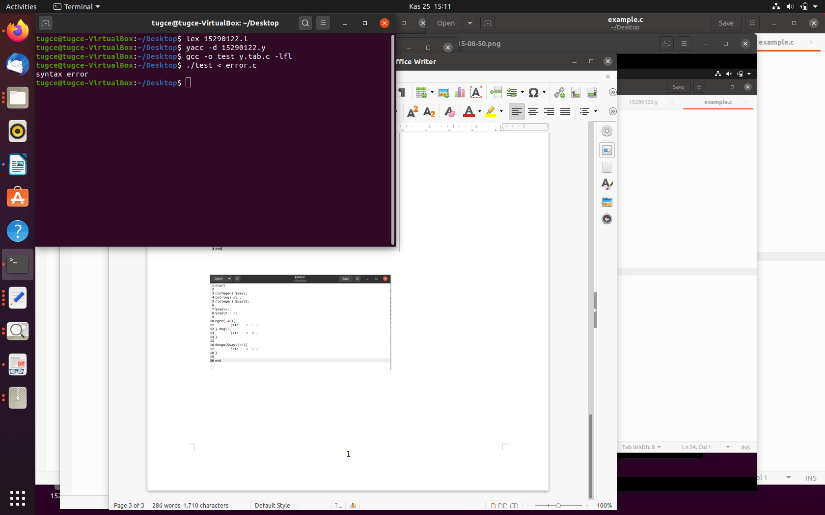

Figure 5. Compiler showing that error file run incorrectly when run

Both files created are provided in the zipped file.

The following instructions should be done to test from the compiler without using a file. For this study, examples for 'OK' and 'syntax error' are shown below.

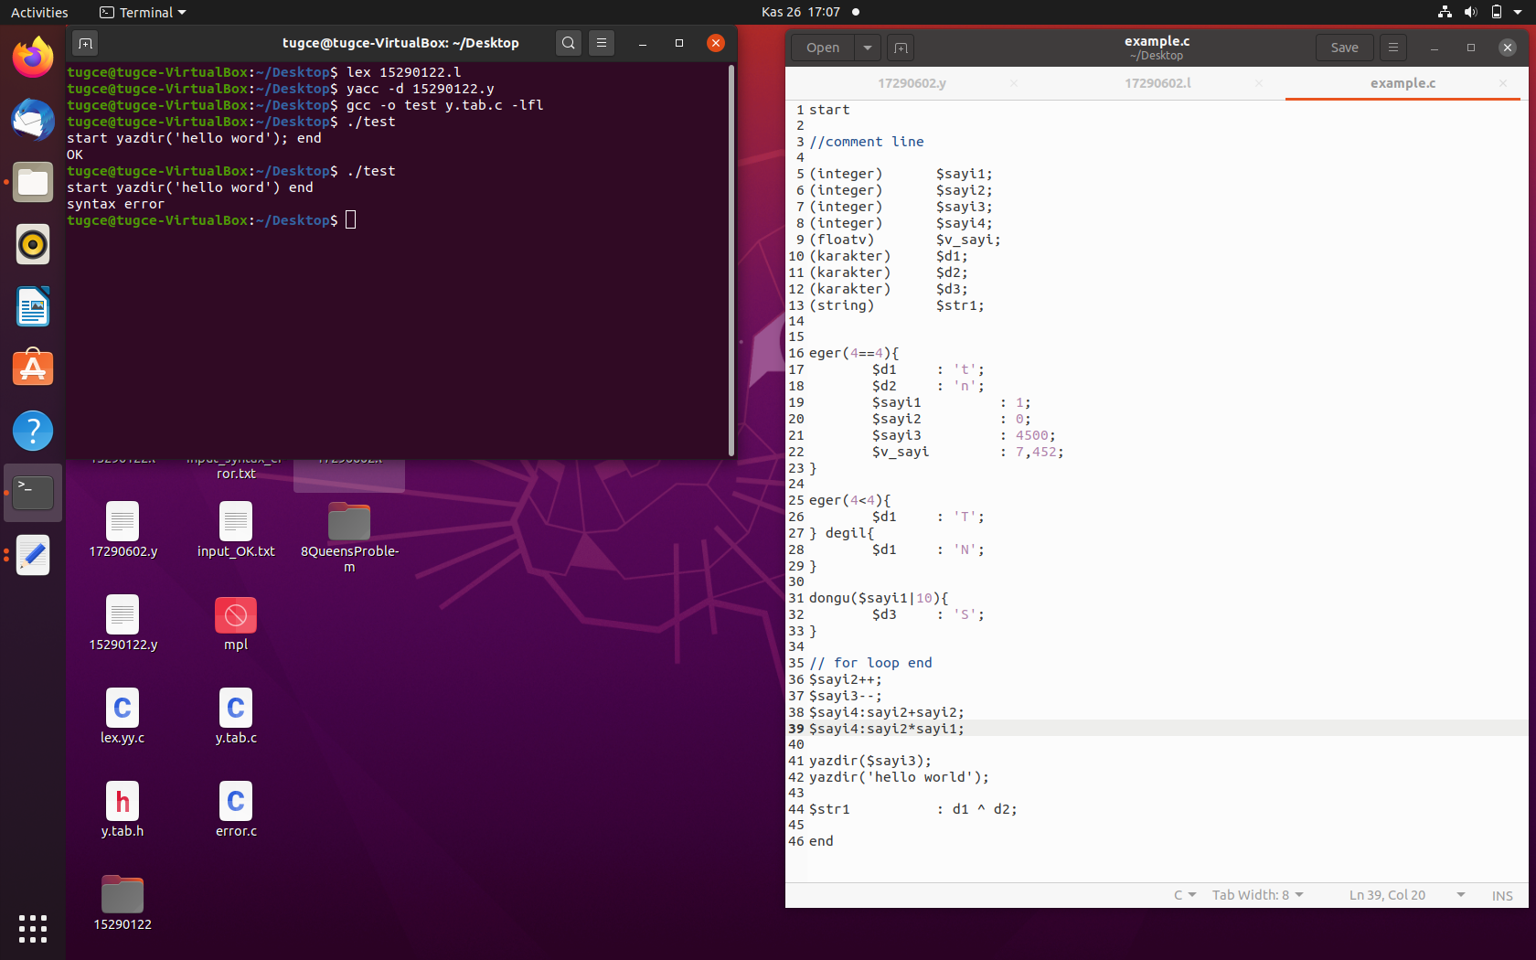

Figure 6. Running from compiler without running from file